SW Beamforming on OneAPI (xPU)
Release Notes
  - Release Notes
9 December 2025

Version History/Revision History
These are the main releases of SW Beamforming on OneAPI (xPU):
Date | Revision | Description
May, 2022 | 1.0 | Initialize version

Intended Audience
Software developers from

Customer Support
For technical support, including answers to questions not addressed in this product, report issues on github,

Contents:
1 Introduction 4
2 New in This Release 5
3 Fixed Issues 6
4 Known Issues 7
5 Related Documentation 8
6 Where to Find the Release 9
7 Release Content 10
8 Best Known Configuration 11
9 Hardware and Software Compatibility 12
10 Acronyms and Terms 13
11 Legal Information 14

Introduction

The purpose of this document is to guide users in using SW Beamforing on OneAPI for xPU project. This project contains 2 ultrasound software beamforming samples, which process ultrasound raw data into images human readable. The project use Intel OneAPI to do computation acceleration with Intel GPU and FPGA. The functions are developed based on Supra.
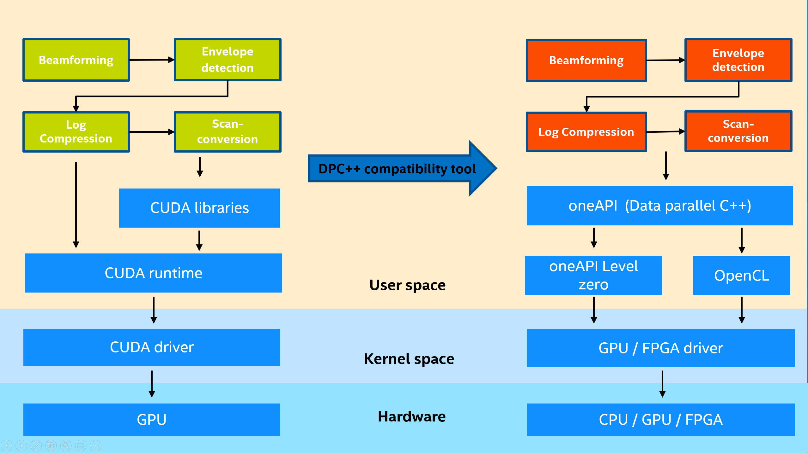
Using oneAPI toolkit -- Intel® DPC++ Compatibility Tool to implement the migration from CUDA to standard DPC++ has been released. For more details, please refer to: https://github.com/intel/supra-on-oneapi. The purpose of this project is for extracting and rewriting the kernel code for easily utilization and running on Intel xPU devices.
To learn more about this product, see:
- New features listed in the New in this Release section below
- Reference documentation listed in the Related Documentation section below

New in This Release

New Features
- Provide software beamforming lib code for Intel iGPU based on OneAPI 2025.3
- Provide getting start guide

Fixed Issues
Reference ID | Description | Status | Solution
1 | From OneAPI 2025.3, the compiler “dpcpp” is marked as no longer supported in the future. | Fixed. | Use the new compiler icx-cl on Windwos and icx/icpx on Linux.

Known Issues
NULL

Non-Intel Issues
NULL

Related Documentation
SW Beamforming on oneAPI(xPU) Getting Start Guide.pdf

Where to Find the Release
Please use git to download source code from git project, https://github.com/intel/SW_Beamforming_on_oneAPI(xPU)

How to Install this Release
- Please refer to SW Beamforming on oneAPI(xPU) Getting Start Guide.pdf.

Release Content
Table 1-1 Revision numbers of components of the Production Candidate release.
Subproject (component) | Location | Revision
Source Code | https://github.com/intel/SW_Beamforming_on_oneAPI(xPU)
Getting start guide | https://github.com/intel/SW_Beamforming_on_oneAPI(xPU)

External Dependencies
- oneAPI. https://software.intel.com/content/www/us/en/develop/tools/oneapi/base-toolkit.html
- stb. https://github.com/nothings/stb
- Supra. https://github.com/IFL-CAMP/supra

Best Known Configuration
Please refer to SW Beamforming on oneAPI(xPU) Getting Start Guide.pdf.

Hardware and Software Compatibility
- For system requirement, please refer to https://software.intel.com/content/www/us/en/develop/articles/intel-oneapi-base-toolkit-system-requirements.html
- We have verified on below systems:
An X86 desktop with iGPU under below configuration:
CPU: Intel® Core™ Ultra 7 Processor 255H with Intel® Arc™ 140T GPU
CPU: Intel® Core™ Ultra 5 Processor 125H with Intel® Arc™ graphics
OS: Windows 11 24H2

Supported Operating Systems
Windows 11 24H2

Acronyms and Terms
The following acronyms and terms are used in this document (arranged in alphabetic order):
Acronym/Term | Description
Intel® oneAPI™ | oneAPI is a cross-industry, open, standards-based unified programming model that delivers a common developer experience across accelerator architectures—for faster application performance, more productivity, and greater innovation. Please refer to https://www.oneapi.com/.  Intel® oneAPI products will deliver the tools needed to deploy applications and solutions across the architectures. Please refer to https://software.intel.com/content/www/us/en/develop/tools/oneapi.html
SUPRA | An open-source pipeline for fully software defined ultrasound processing for real-time applications. Covering everything from beamforming to output of B-Mode images, SUPRA can help reproducibility of results and allows modifications to the image acquisition.
DPC++ | At the core of the oneAPI specification is DPC++, an open, cross-architecture language built upon the ISO C++ and Khronos SYCL standards.
Intel® DPC++ Compatibility Tool | The Intel® DPC++ Compatibility Tool assists in migrating your existing CUDA code to Data Parallel C++ (DPC++) code. Refer to https://software.intel.com/content/www/us/en/develop/tools/oneapi/components/dpc-compatibility-tool.html

Legal Information
Component | License
SW Beamforming on oneAPI(xPU) | LGPL 2.1

